RHETORICAL ANALYSIS HW #2 Name:

Directions:
- Read and analyze the article below.
- Answer the questions included throughout (fully and in complete sentences).

Six Social Sources of the U.S. Crime Drop
by Chris Uggen and Suzy McElrath, Feb 4, 2013, at 01:51 pm

Each year, when the federal government releases new crime statistics, reporters seek out crime experts to help interpret the numbers. But following three decades of climbing crime rates, the downward trend of the past two decades has left even the experts searching for answers. Crime dropped under Democrats like Bill Clinton and Barack Obama andwhen Republicans like George W. Bush were in charge. Crime dropped during times of peace and times of war, in the boom times of the late 1990s and in the Great Recession era from 2007 to 2009. In recent years, both criminologists and the public have been baffled by the improving crime situation—especially when many other social indicators looked so bleak.

But social scientists are starting to make sense of the big U.S. crime drop. At least among many of the “street” crimes reported by police and victims, today’s crime rate is roughly half what it was just two decades ago. This isn’t because people are twice as nice. Rather, the reasons behind the crime drop involve everything from an aging population to better policing to the rising ubiquity of cell phones. There’s no single “smoking gun” that can account for the drop: both formal social controls, such as police and prisons, and broader shifts in the population and economy play a part. That is, the main drivers are all social. Crime is less likely these days because of incremental changes in our social lives and interaction with others, including shifts in our institutions, technologies, and cultural practices. Before unpacking these social sources of the crime drop, we need to look a little more closely at its timing and variation across offenses, from auto theft to murder.

[Part of this study has been edited out for classroom purposes]

Six Social Sources
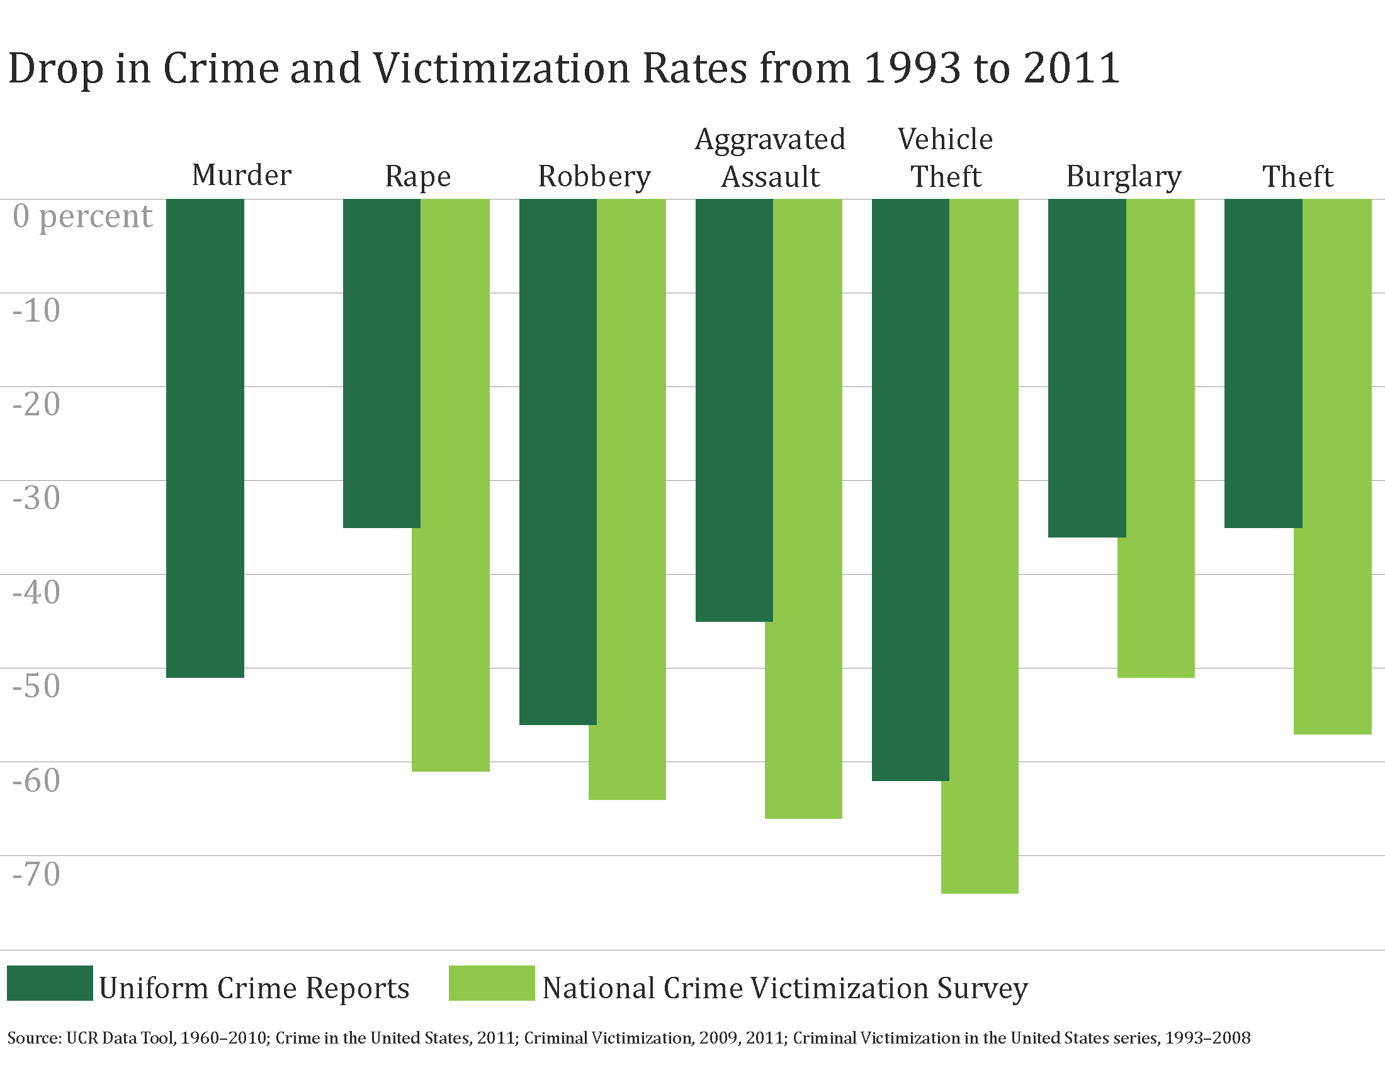
The big crime drop implies that either fewer people are participating in crime or that those who do participate are committing crime less frequently. But a society’s rate of crime is not a simple aggregation of the number of “crime-prone” individuals with particular psychological or biological characteristics. Under the right or, more precisely, the wrong social conditions, we are all prone to commit criminal acts. Communities therefore attempt to organize social life in ways that make crime less likely. While we often associate crime with institutions such as the police or courts, anything that alters patterns of human interaction can drive the crime rate up or down. This includes the technology in our cars, the places we go for entertainment, and the medical advances affecting reproduction and aging.

The idea that crime is social rather than individual is a prominent theme in much of the best new research. The crime drop partly reflects the work of institutions that are explicitly designed to increase social control, but it also reflects changes in other institutions designed to perform different societal functions.
Scholars have yet to neatly partition the unique contribution of the six social sources of the crime drop, but we can summarize current thinking about their likely impact.
Formal Social Control and Criminal Opportunities
  - Punishment
Punishment. No discussion of recent U.S. crime trends would be complete without considering our nation’s prison population, which increased from 241,000 in 1975 to 773,000 in 1990 to over 1.6 million in 2010. Because incarceration rose so rapidly, it is tempting to attribute the lion’s share of the crime drop to the incapacitating effects of prison. But if this were the case, as law professor Franklin Zimring points out, we should have seen an earlier crime drop (when incarceration first boomed in the 1970s). Instead, since crime is closely tied to the demography of the life course, new cohorts of potential offenders are always replacing those removed via incarceration. Moreover, many criminologists believe that prisons are actually criminogenic in the long-run, strengthening criminal ties and disrupting non-criminal opportunities when inmates are released. In one of the most sophisticated studies of the effect of imprisonment on crime, sociologist Bruce Western estimates that roughly nine-tenths of the crime drop during the 1990s would have occurred without any changes in imprisonment. Economist Steven Levitt attributes up to one-third of the total decline to incarceration. Rising rates of imprisonment thus account for at least some of the crime drop in the 1990s and 2000s, with scholars attributing anywhere from 10 to 30% of the decline to America’s incarceration boom.

- If harsher prison systems and penalties were the cause of the crime drop, what should “we” have seen earlier?

- Based on the context provided in the text, create a definition for the world “criminogenic.”

- What does Bruce Western believe about the relationship between the crime drop and imprisonment? and Steven Levitt?

  - Policing
Policing. Both public and private policing strategies have changed considerably over the past several decades, as have the technologies available to law enforcement. Zimring and others conclude that “cops matter,” especially in explaining New York City’s crime decline. More specifically, criminologists David Weisburd and Cody Telep identify targeted policing of high-crime “hot spots,” gun crimes, and high-rate offenders, as well as proactive problem-oriented policing and the use of DNA evidence as police practices that reduce crime. In contrast, they find little evidence for the effectiveness of policing tactics like random preventive patrol, follow-up visits in domestic violence cases, and Drug Abuse Resistance Education (the DARE program).While Levitt is skeptical about the role of new policing strategies, he attributes a portion of the 1990s crime drop to increases in the number of officers on the street. Because of the criminogenic effects of prison, scholars such as economist Steven Durlauf and criminologist Daniel Nagin propose shifting a greater share of criminal justice funding in policing. Effective law enforcement is part of the picture, says criminologist John MacDonald, but he also argues that public-private security partnerships such as targeted “business improvement districts” have helped to sustain the decline. The unique contribution of policing to the current crime drop is likely significant, but limited—accounting for perhaps 10 to 20% of the overall decline. Moreover, the effectiveness of the formal social controls provided by police depends, in large part, on support from informal social controls provided by families and communities.

- What did Weisburd and Telep discover about “policing tactics” and their effectiveness?

- How much of an effect does this study believe policing had on the overall decrease in crime?

- Opportunities
Opportunities. Apart from changes in prisons and policing, the opportunities for crime have changed rapidly and dramatically since the 1990s. Technology isn’t an obvious social source of the crime drop, but people have been connecting in fundamentally different ways in the past two decades, altering the risks and rewards of criminal behavior. When it comes to “target hardening” (crime prevention through environmental design), simple changes can make an enormous difference. Recall that the biggest drop among all crime categories was in auto theft—in the United States and around the world, new technologies like car immobilizers, alarms, and central locking and tracking devices have effectively reduced this crime. More generally, surveillance provides guardianship over ourselves and our property. It may even deter others from acting against us. With regard to a now-common technology, economists Jonathan Klick and Thomas Stratmann and criminologist John MacDonald point to the amazing proliferation of cell phones. They argue that cells increase surveillance and a would-be offender’s risk of apprehension, which affects the perceived costs of crime. Many potential victims now have easy access to a camera and are within a few finger-swipes of a call to 9-1-1. In a follow-up interview with the authors about his research, MacDonald said that the crime drop is “driven in part by target hardening, in part by consumer technological shifts, and in part by the movement of people’s nighttime activities back to the house.” In sum, where we spend our time and who is watching us likely plays a big role in the recent crime decline. Of course, efforts to constrain criminal opportunities can also constrain non-criminal activities—and while most of us welcome the declining crime rates that accompany greater surveillance, we are far more ambivalent about being watched ourselves. As criminologist Eric Baumer explained to the authors, “not only are we spending more time off the streets and on a computer, but we are being watched or otherwise connected to some form of ‘social control’ pretty constantly when we are out and about.” It is difficult to quantify how myriad small changes in criminal opportunities affected the crime drop, but their combined contribution may be on a par with that of formal policing or prisons.

- How have cell phones helped with the drop in crime?
- Generally speaking, how does this section believe “opportunities” effects the crime drop? (What does “opportunities” mean?)

Social Trends and Institutional Change
  - Economics
Economics. More than 90% of the “Part I” crimes reported to the police involve some kind of financial gain. The relationship between crime and the economy is more complicated than the simple idea that people “turn to crime” when times are tough, though. Contrary to popular expectations, for example, both victimizations and official crime showed especially steep declines from 2007 to 2009, when unemployment rates soared. Robbery, burglary, and household theft victimizations had been falling by a rate of about 4% per year from 1993-2006, but fell by an average of 6 to 7% per year during the Great Recession. This is not because crime is unrelated to economic conditions, but because crime is related to so many other things. For example, when people have less disposable income, they may spend more time in the relative safety of their home and less time in riskier places like bars. As noted above regarding opportunities, another reason crime rates are likely to drop when cash-strapped residents stay home at night in front of a television or computer screen is that their mere presence can help prevent burglary and theft. Criminologists Richard Rosenfeld and Robert Fornango suggest that consumer confidence and the perception of economic hardship may account for as much as one-third of the recent reduction in robbery and property crime. Nevertheless, while economic recessions and consumer sentiment are likely to play some role, they cannot account for the long and steady declines shown in the charts above—boom or bust, crime rates have been dropping for twenty years. For this reason, most criminologists attribute only a small share of the crime drop to economic conditions.

- Why does the article think there is more to increases in crime than just being financially disadvantaged? What other factors affect increases in crime?

- According to the article, why might crime decrease if people stay at home?

- Demography
Demography. Crime, it seems, is largely a young man’s game. For most offenses, crime and arrests peak in the late teen years and early twenties, declining quickly thereafter. During the 1960s and 1970s, the large number of teens and young adults in the Baby Boom cohort drove crime rates higher. In societies that are growing older, such as the contemporary United States, there are simply fewer of the young men who make up the majority of criminal offenders and victims. Due to these life course processes, the age and gender composition of a society is an underlying factor that structures its rate of crime. An influx of new immigrants might also be contributing to lower crime rates. According to research by sociologist Robert Sampson and his colleagues, immigration can be “protective” against crime, with first-generation immigrants being significantly less likely to commit violence than third-generation Americans, after adjusting for personal and neighborhood characteristics. While criminologists estimate that demographic changes can account for perhaps 10% of the recent crime drop, these factors are changing too slowly to explain why crime was essentially halved within the course of a single generation.

- Based on the info included in this section, describe what an average criminal’s characteristics are (age & gender).
- According to the article, are recent immigrants more or less likely to commit violence/crime?

- Social Dynamics
Longer-term Social Dynamics. Drawing back the historical curtain on U.S. crime rates puts the recent drop in perspective. So argued historian Eric Monkkonen, who showed that the urban homicide rates of the nineteenth and early twentieth centuries were on a par with the “peak” rates observed in the early 1990s. In fact, historical evidence amassed by scholars including psychologist Steven Pinker and historical criminologist Manuel Eisner convincingly shows that personal violent crime began declining in Western nations as early as the sixteenth century. While this research has emphasized violent crimes, similar processes may hold for crime more generally. Perhaps the rising crime rate from World War II through the early 1990s was simply a small spike that temporarily obscured a much longer downward trend. This long historical sweep may offer little solace to those confronted by crime today, but the encouraging long-term trend suggests explanations with deep roots. Eisner points to subtle shifts in parenting occurring over a long time span; Pinker suggests greater interdependence and broadened circles of people with whom we can empathize. Both draw on classic sociological work by Emile Durkheim and Norbert Elias, who attributed historical changes in crime and social disorder to changes in the relation between individuals and society. The centuries-long crime story is perhaps best explained by the gradual development of formal and informal social controls on our behavior. In this light, Baumer argues that we should at least think more expansively about the contemporary crime drop. We cannot say for certain where the crime rate will be in five years, but if we had to bet where the crime rate would be in one hundred years, we could be reasonably confident it’d be measurably lower than it is today.

12. What are a few examples of social changes that have led to the gradual drop in crime over time?

Room for Improvement
Criminologists almost universally acknowledge a sizeable crime drop over the last twenty years. This does not mean that everyone’s neighborhood became safer or that crime in the United States is low relative to other industrialized nations. In fact, U.S. homicide rates are more than double those of Canada, Japan, and much of Europe. Nevertheless, the U.S. crime picture has improved markedly, with significant across-the-board drops in violent and property offenses. Moreover, as Baumer points out, even behaviors like drinking, drug use, and risky sex are declining, especially among young people.
We cannot explain such a sharp decline without reference to the social institutions, conditions, and practices shaping crime and its control. In particular, social scientists point to punishment, policing, opportunities, economics, demography, and history, though there is little consensus about the relative contribution of each. Further disentangling each factor’s unique contribution is a worthy endeavor, but it should not obscure a fundamental point: it is their entanglement in our social world that reduces crime.

