NAME: __________________ PER: ___
OUTLINING YOUR NARRATIVE

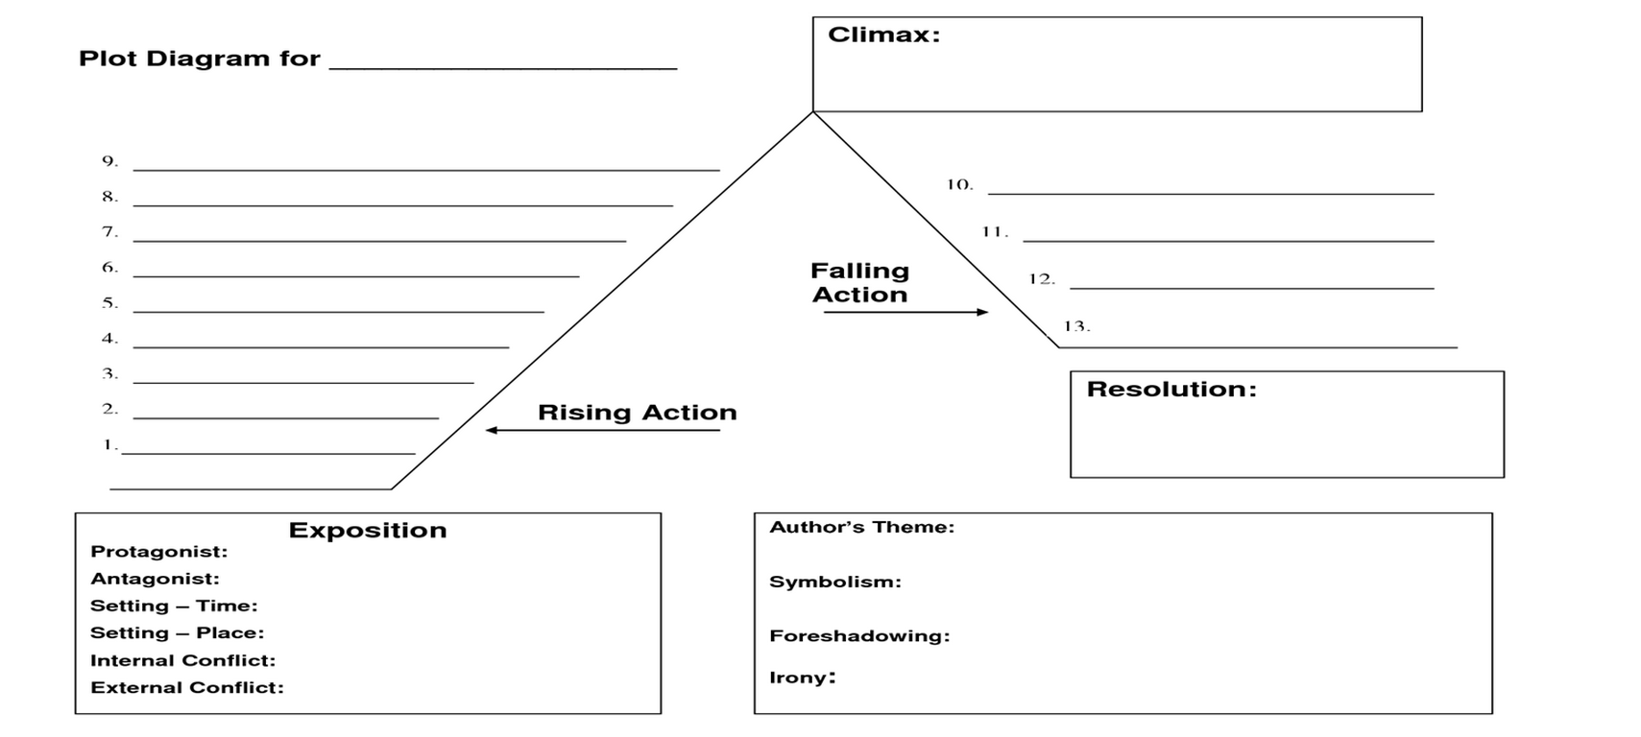

STEP 1: CLIMAX | STEP 2:  EXPOSITION | STEP 3:  RESOLUTION | STEP 4:  RISING ACTION | STEP 5:  FALLING ACTION
- Decide on the turning point or main action of your story  - Fill in for “CLIMAX” | - Decide on where you would like to start your story  - Fill in the box for “EXPOSITION” | - Decide on the last moments of your story  - What lesson could be learned?  - What might you reflect on?  - If comedy, what’s the punchline?  - Fill in for “RESOLUTION” | - What actions will make your climax more interesting?  - How will you organize your story to build suspense?  - Fill in for “RISING ACTION” | - What events resolve your climax?  - What happened because of your climax?  - What events will help explain any lose ends?

TEACHER EXAMPLE

