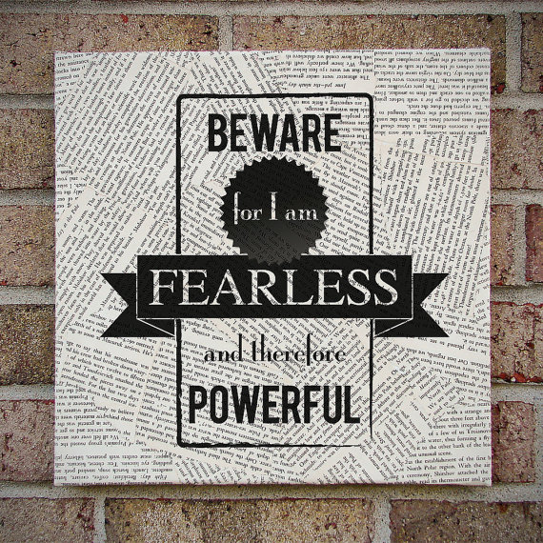

NAME: __________________________________________

PER: ________

ELA 10 – Ms. Larson-Long

FRANKENSTEIN
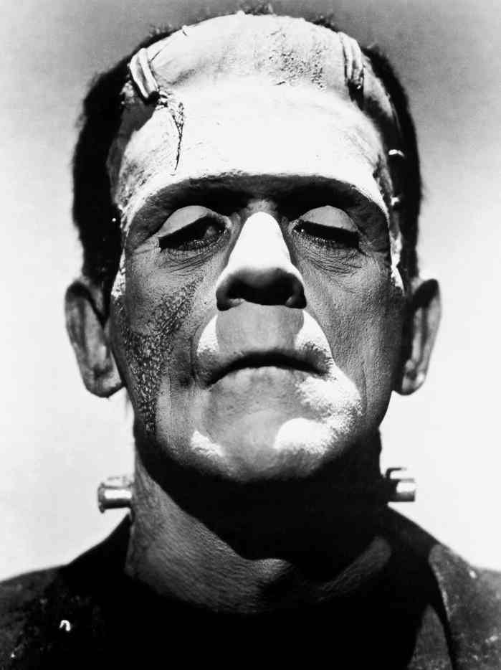
READING PACKET
CHARACTER GUIDE
DIRECTIONS: In the space provided, describe the role of each of these characters and their effect on the story.

Victor Frankenstein:

The Monster:

Robert Walton:

Alphonse Frankenstein:

Elizabeth Lavenza:

Henry Clerval:

William Frankenstein:

Justine Moritz:

Caroline Beaufort:

Beaufort:

Peasants:

M. Waldman:
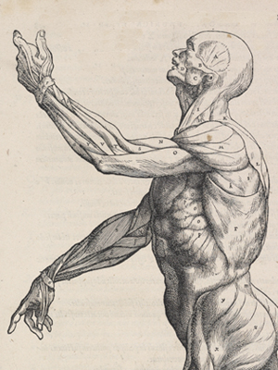
M. Krempe:

Mr. Kirwin:
TIMELINE OF MAJOR EVENTS
END
BEGINNING

EVIDENCE COLLECTION
As you read, you should begin collecting evidence that helps you answer our unit question:
ESSAY PROMPT: Of the robots and creatures we have read about during this unit, which one is the most human? In your essay you should create a precise and insightful definition of what it means to be human (thesis) and then effectively defend your response with evidence from our unit texts (body).

You should have at least 1 quote for every 2 chapters.

CHAP | PG | QUOTE
Letters
1-2
3-4
5-6
7-8
9-10
11-12
13-14
15-16
17-18
19-20
21-22
23-24

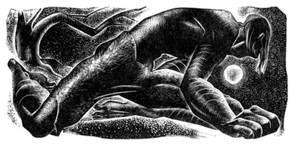
***If you run out of space, use post-its to include parts of the quote.
LETTERS 1 – 4
SUMMARY
COMPREHENSION QUESTIONS:

- Who is writing the letters?

- To whom is he writing?

- Where is Robert Walton when he writes letter 1? Why is he there? What are his plans?

- How much time has passed between Letter 3 and Letter 4? What “strange accident” has happened to the sailors?

- What sort of man is rescued by Walton and his crew? How does Walton respond to him?
DISCUSSION QUESTION: | 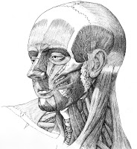  TERMS/VOCAB
CHAPTER 1-2
SUMMARY
COMPREHENSION QUESTIONS:
- What is the man’s background? (Do we know his name ye?) Where is he from?

- What is the story behind the man’s mother, Caroline Beaufort?

- How does the man feel towards his parents?

- Who is Elizabeth Lavenza and what is her story?

- Who is Cornelius Agrippa and how does Victor find out about him? How does Victor’s father respond?

- What happens when Victor sees an oak tree destroyed by lightning? What does Victor begin to study?
DISCUSSION QUESTION: | TERMS/VOCAB
CHAPTERS 3 – 4
SUMMARY:
COMPREHENSION QUESTIONS:

- What happens to Victor’s mother as a result of Elizabeth’s scarlet fever? How does this compare with the mother’s early history?

- What does Victor learn from M. Krempe? How does Victor respond to him?

- What does Victor discover while at school?

- Will he share the knowledge of creating life with Walton? Why?

- How does he go about creating a human being and what does he expect will be the result of this creation? How long does the task take? What happens to Victor in the process?
DISCUSSION QUESTION: | TERMS/VOCAB
CHAPTERS 5 – 6
SUMMARY
COMPREHENSION QUESTIONS:

- How does Victor respond to the actual creation of life? What surprises him about the appearance of the creature he has brought to life?

- What does Victor dream? How does the dream explain what Victor has done and been through?

- What does the creature do? How does Victor respond?

- Who does Victor meet arriving in a coach the next morning? How does Victor respond? What does Victor discover when they go to the apartment? How does Victor respond?

- Who is William and how old is he?

- What does Victor do after his recovery? What is Clerval’s “plan of life”?
DISCUSSION QUESTION: | TERMS/VOCAB
CHAPTERS 7 – 8
SUMMARY
COMPREHENSION QUESTIONS:

- How long has Victor been away from home? What happens the night he returns to Geneva? How does he respond?

- Whom does Victor see that night? When was the last time they saw each other? How long ago?

- What does Victor now believe happened to William? What does Victor assume about the nature of the creature?

- Who is identified as the murderer and on what evidence? How does Victor respond and why doesn’t he say anything about the real murderer?

- What happens at Justine’s trial? How does Victor respond?
DISCUSSION QUESTION: | 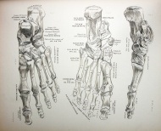  TERMS/VOCAB
CHAPTERS 9 – 10
SUMMARY
COMPREHENSION QUESTIONS:

- How does Victor respond in the days after Justine’s death? How have Elizabeth’s views changed?

- What journey does Victor undertake, and when? What places does he travel through? Where does he stay?

- How does Victor feel during his travels through Montanvert?

- Whom does Victor see? How does he respond?

- In this chapter, we finally hear the creature speak for the first time. What does he say? Is this what you expected?

- What will cause the creature to change? Keep in mind his statement “I Was benevolent and good; misery made me a fiend. Make me happy, and I shall again be virtuous.”

DISCUSSION QUESTION: | TERMS/VOCAB
CHAPTERS 11 – 12
SUMMARY:
COMPREHENSION QUESTIONS:
- How does the creature respond to his discovery of fire? Why does he move?

- What happens during his first encounters with people? Is this more like what you expect from a horror story?

- Where does he finally find a place to stay? What does he learn about the people who live in the cottage and how does he feel about them?

- What things bother the creature when he thinks of discovering himself to the family? How does he respond to his own appearance when he sees it?

- How does the creature hope to win over the family? How does he respond to the coming of spring?

DISCUSSION QUESTION: | 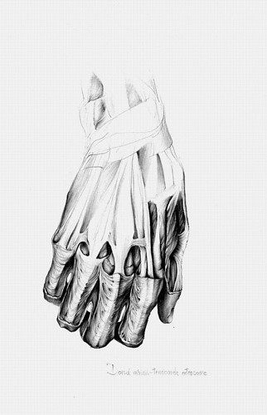  TERMS/VOCAB
CHAPTERS 13 – 14
SUMMARY:

COMPREHENSION QUESTIONS:
- Who arrives at the cottage in the spring? What is her background? How does her language problem help the creature? Which of them learns faster?

- How does the creature learn about reading? What book does Felix use to teach Safie?

- What happens when the creature begins to think about himself? How does he compare with the humans described in the book? What questions does he ask himself? How does his knowledge make him feel?

- What does he learn about human relationships and how does this make him feel?
DISCUSSION QUEST ION: | TERMS/VOCAB
CHAPTERS 15 – 16
SUMMARY
COMPREHENSION QUESTIONS:
- What does the creature find in the woods?

- What are the three books the creature reads, and what does he learn from each?

- What else does the creature read and what does he learn from it?

- What does the creature hope will happen when he talks to De Lacey? What actually happens?

- What event during the creature’s travels confirms his hatred of humans?

- What event happens when the creature is near Geneva? Who is the boy? Who is the woman?

- What does the creature demand of Victor?
DISCUSSION QUESTION: | 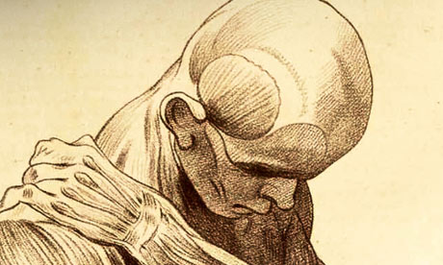  TERMS/VOCAB
CHAPTERS 17 – 18
SUMMARY
COMPREHENSION QUESTIONS:
- How does Victor at first respond to the creature’s deman? What response does he expect from the creature? What approach does the creature say he will take?

- How effective is the creature in convincing Victor?

- What does the creature say will happen if Victor creates a female for him?

- Why does Victor want to visit England? What do you make of his talk of slavery?

- What is the effect of Victor’s return to the present?

DISCUSSION QUESTION: | TERMS/VOCAB
CHAPTERS 19 – 20
SUMMARY
COMPREHENSION QUESTIONS:
- Why does Victor change his mind about creating the female? Who watches him as he destroys the female?

- What happens shortly after Victor destroys her?

- What happens when the creature visits Victor? What does the Creature promise to do? What does Victor understand that promise to mean?

- What happens when Victor goes out in a boat to dispose of the female creatures remains? Where does he end up? What happens when he lands?

DISCUSSION QUESTION: | 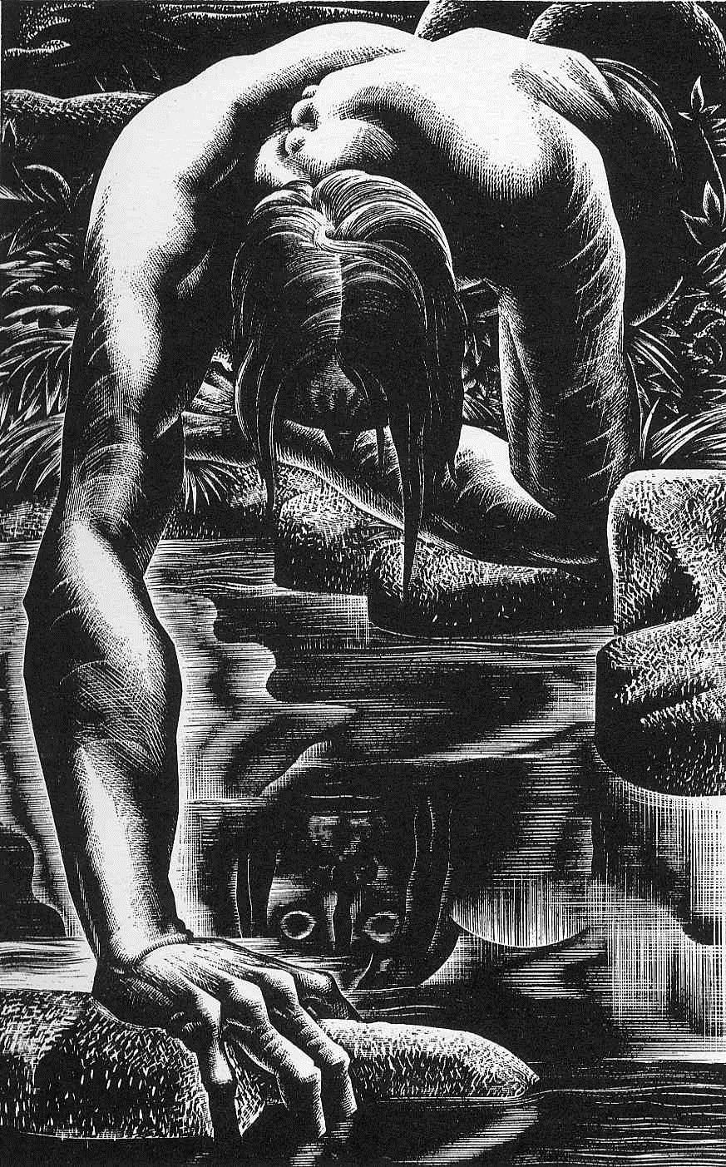  TERMS/VOCAB

CHAPTERS 21 – 22
SUMMARY
COMPREHENSION QUESTIONS:
- Who is Mr. Kirwin and how does he treat Victor? What has happened to cause Victor’s arrest? What happens to Victor after his arrest?

- What happens to Victor when he wakes up? Who is there?

- What happens at Victor’s trial?

- How does Victor feel as they leave Ireland and go to France?

- What does Elizabeth say in her letter? How does Victor respond?

- What are their marriage plans? How does Victor prepare for what he fears will happen?
DISCUSSION QUES TION: | TERMS/VOCAB

CHAPTERS 23 – 24
SUMMARY
COMPREHENSION QUESTIONS:
- Has Victor understood the Creature’s promise correctly? What happens on Victor’s wedding night?

- How does the creature respond?

- What happens when Victor returns to Geneva? What happens to Victor’s father? What happens to Victor?

- What happens when Victor tries to get the authorities to help him hunt for the creature?

- What happens during Victor’s pursuit of the Creature? Where do they go? What does the Creature do?

- What does Victor ask Walton to do? What does he warn Walton about the Creature?

DISCUSSION QUESTION: | 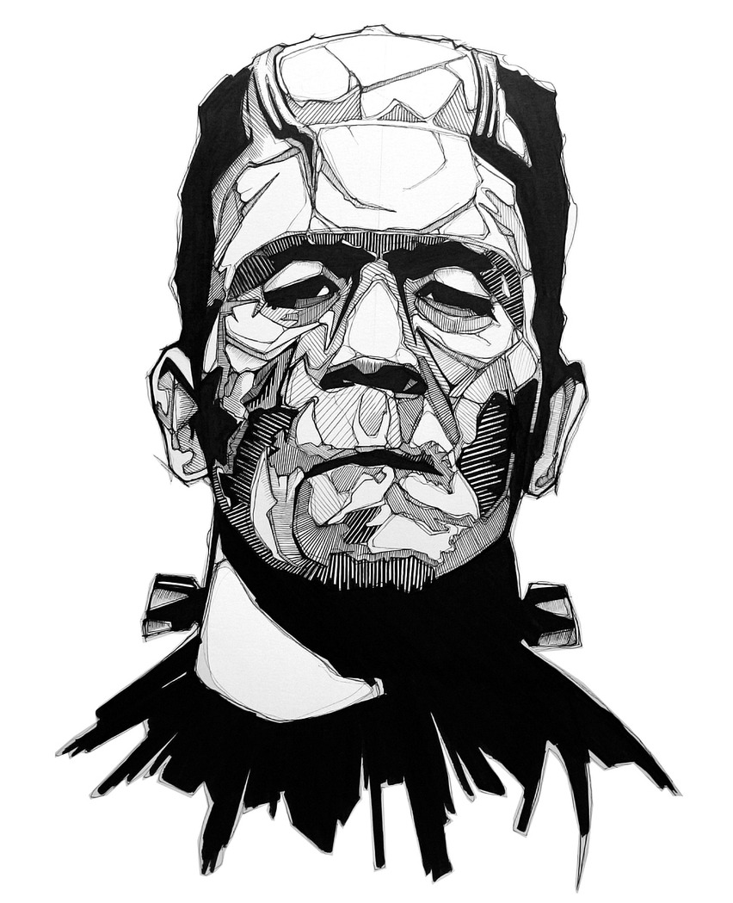  TERMS/VOCAB
Walton, In Continuation
SUMMARY
COMPREHENSION QUESTIONS:
- Why wouldn’t Victor tell Walton the details about the creation?

- Why is Walton returning to England? What will Victor do?

- Does Victor blame himself? What is Walton’s response to Victor’s death?

- When Walton sees the Creature in the cabin with Victor’s body, what is familiar about the scene? Why has the Creature come to see Victor?

- How does the Creature explain what he has done? How does Walton respond to the Creature?

- What will the Creature do next? How does he feel about it?
DISCUSSION QUESTION: | TERMS/VOCAB
HOMEWORK CHECK

 | Letters 1 - 4 |  | Chapters 15-16
 | Chapters 1-2 |  | Chapters 17-18
 | Chapters 3-4 |  | Chapters 19-20
 | Chapters 5-6 |  | Chapters 21-22
 | Chapters 7-8 |  | Chapters 23-24
 | Chapters 9-10 |  | Character Guide
 | Chapters 11-12 |  | Timeline of Events
 | Chapters 13-14

_______ / 15 COMPLETED (on-time)

READING PACKET RUBRIC

To receive full credit, each assignment (half page) must include the following elements:
- A 2-3 sentence summary that successfully reflects the most important events of the chapter.
- All comprehension questions have been answered correctly and in complete sentences.
- At least one higher-level discussion question has been created.
- At least 3 vocabulary words have been identified and accurately defined.

STUDENT SCORE

SCORE | CHAPTER | SCORE | CHAPTER | SCORE | CHAPTER
 | Chapters  1-2 |  | Chapters  9-10 |  | Chapters 17-18
 | Chapters  3-4 |  | Chapters 11-12 |  | Chapters 19-20
 | Chapters  5-6 |  | Chapters 13-14 |  | Chapters 21-22
 | Chapters  7-8 |  | Chapters 15-16 |  | Chapters 23-24

_______ / 48 pts

TOTAL PACKET GRADE:

_______ + _______ + _______ = _______
HW CHECKS CHAP PGS QUOTES ^{TOTAL}

